**Manuratiometer**

Katie Williams

(614) 962-0724

[katie4134@gmail.com](mailto:katie4134@gmail.com)

Katie Atherton

(630) 487-1897

[katherto@purdue.edu](mailto:katherto@purdue.edu)

Haley Brouwer

(260) 210-1209

[bkwormhb@gmail.com](mailto:bkwormhb@gmail.com)

Paige Rudin

(309) 363-0807

[rudin@purdue.edu](mailto:rudin@purdue.edu)

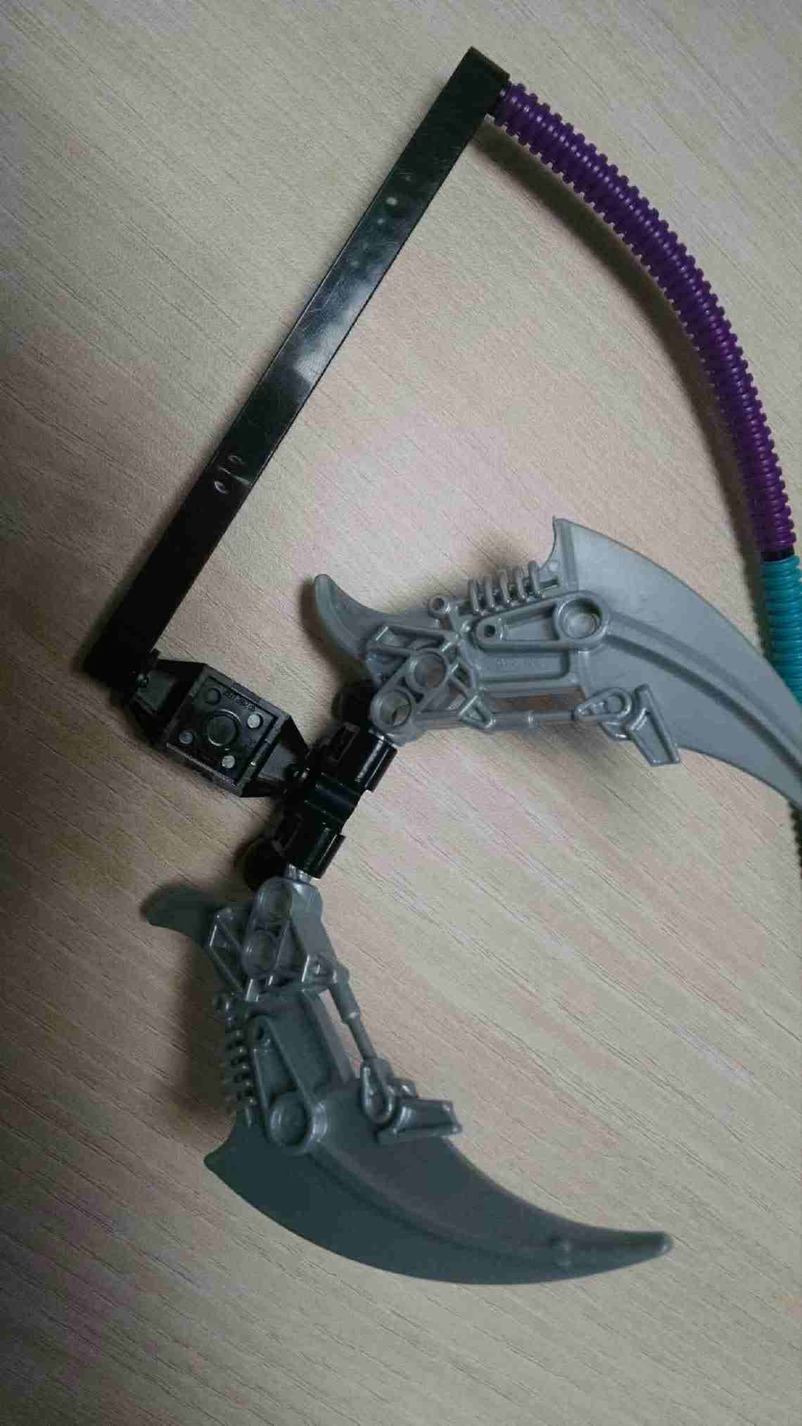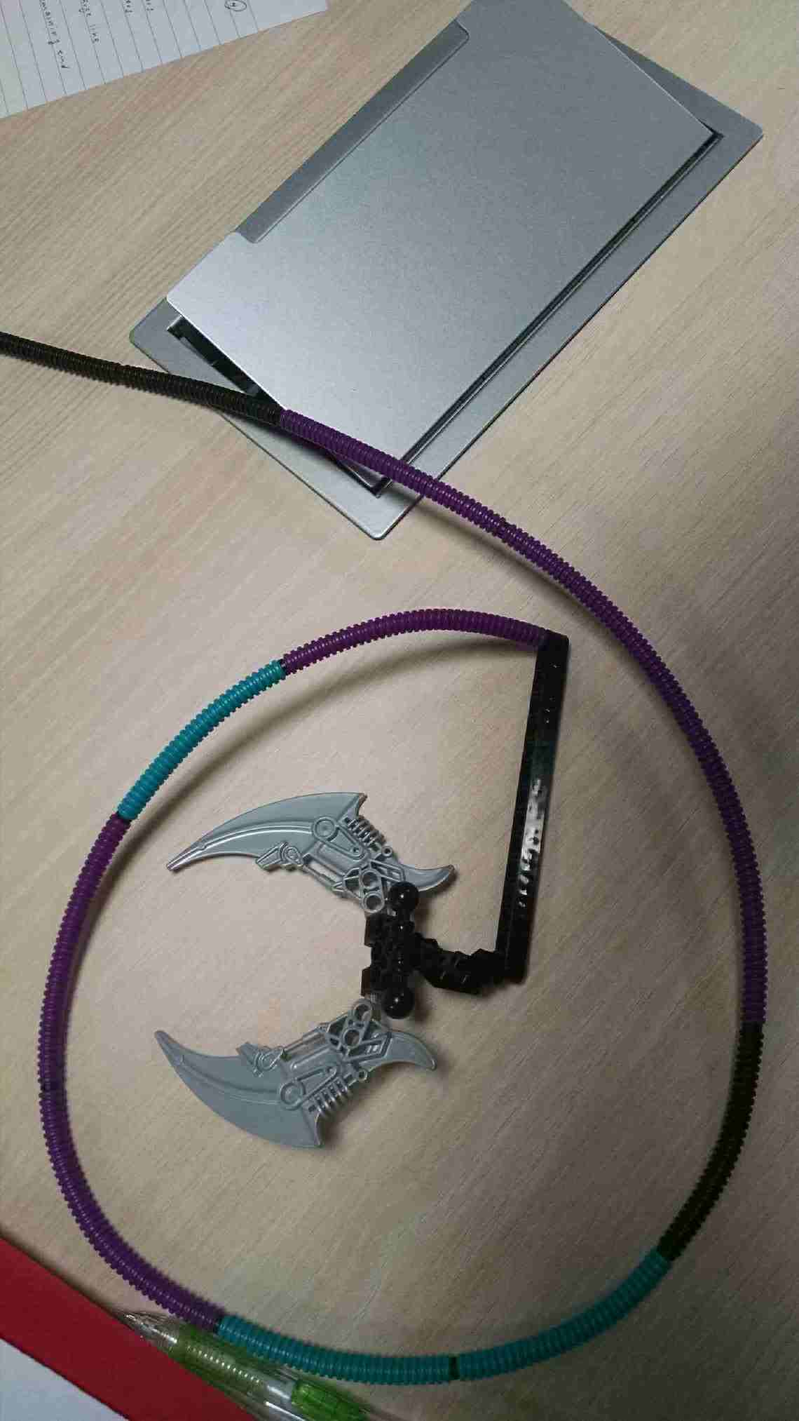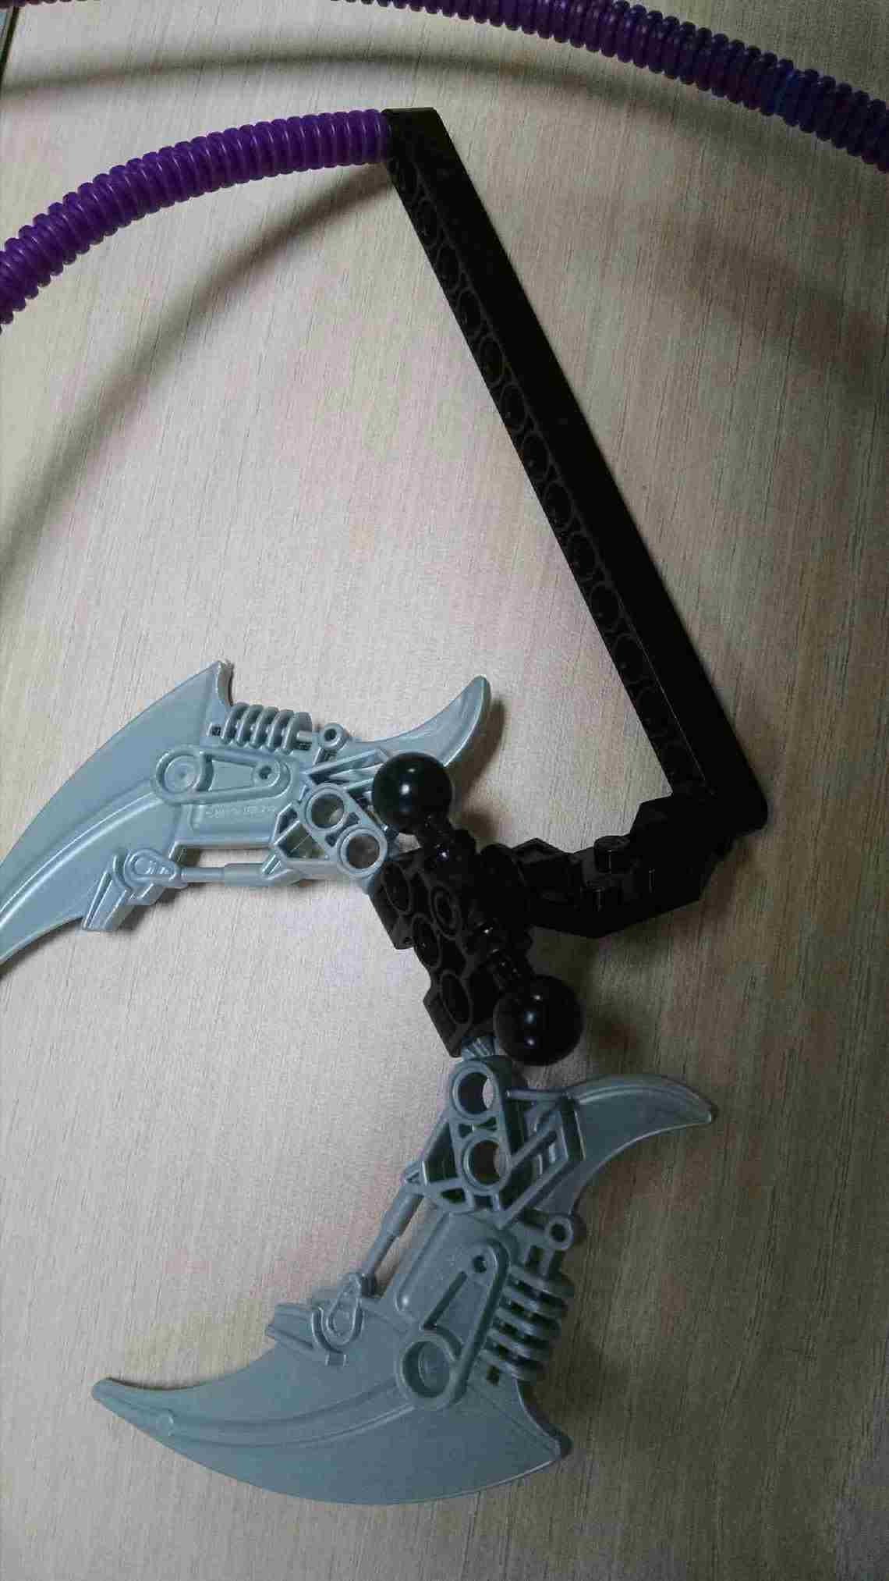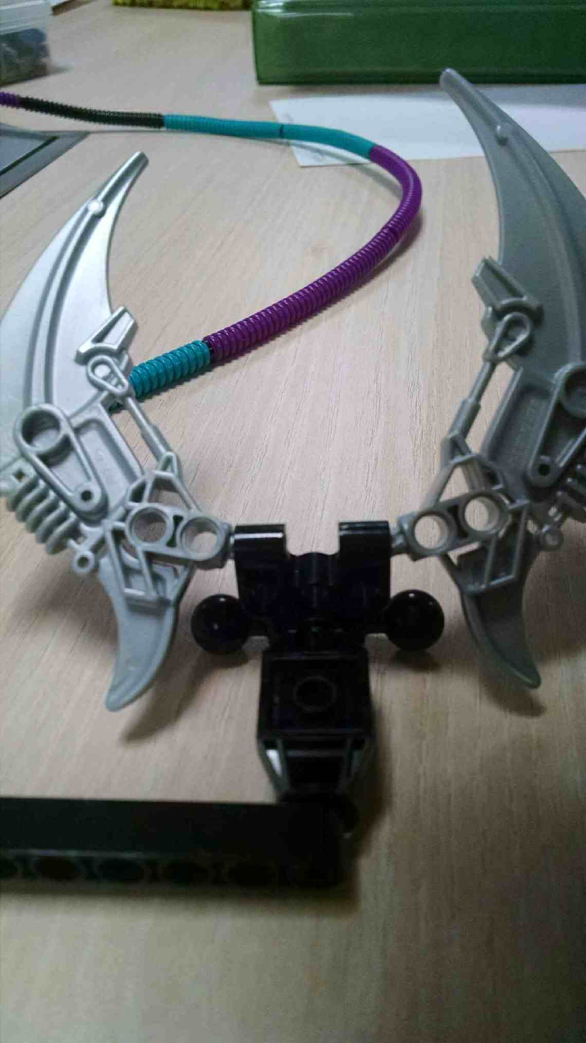

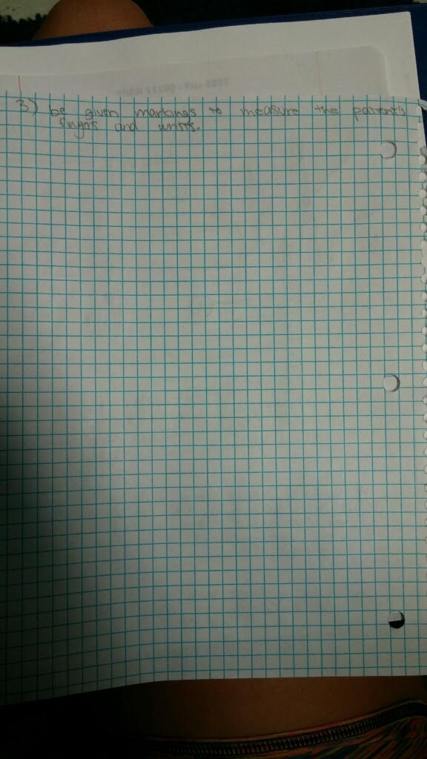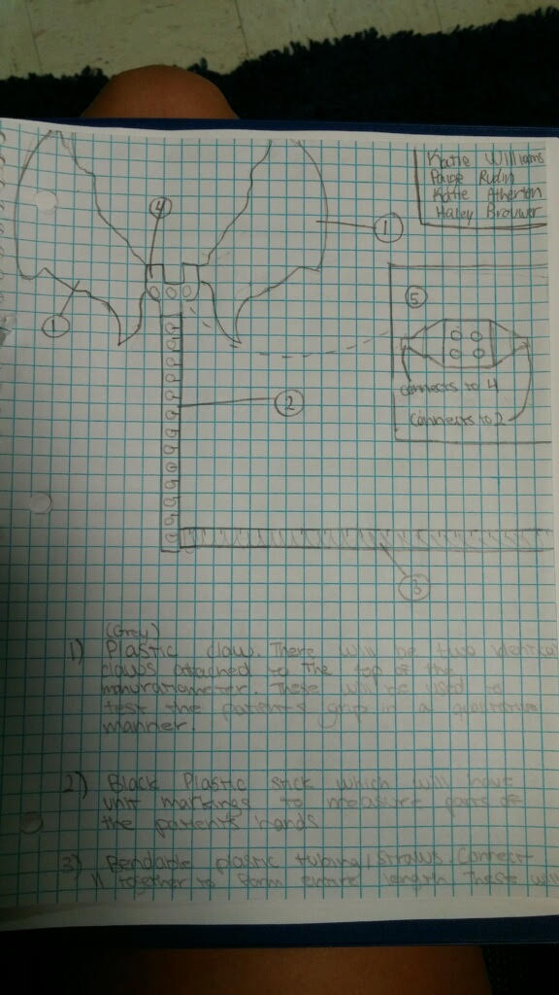**Assembly Graphics**

